**Earthquake prediction model using python**

**Problem Statement:**

An earthquake prediction model is a cutting-edge and essential tool in the field of seismology and disaster management. Earthquakes are natural phenomena that can cause significant damage and loss of life, making their prediction a matter of paramount importance. Such a model aims to harness the power of data analysis, advanced technologies, and scientific knowledge to forecast the occurrence, location, magnitude, and potential impact of seismic events. In this introduction, I will provide an overview of earthquake prediction and how Python can be used in earthquake-related research and analysis.

**Design Thinking Process:**

Designing an earthquake prediction model is a complex task that involves a multi-disciplinary approach, considering geological, seismological, and data science aspects. Design thinking can be a useful framework for developing such a model as it emphasizes understanding the problem, ideation, prototyping, and testing in an iterative process. Here's a general framework for creating an earthquake prediction model using design thinking:

**1. Empathize:**

- Understand the problem: Gather information about the geological and seismological aspects of the region in question.

- Conduct interviews and surveys with experts in the field to gain insights into existing models and data sources.

**2. Define:**

- Clearly define the problem you want to solve. For example, specify the location, timeframe, and magnitude range for earthquake prediction.

- Identify key metrics for model success, such as accuracy, precision, and recall.

**3. Ideate:**

- Brainstorm potential data sources: Consider geological data, historical seismic activity, satellite imagery, weather patterns, and any other relevant information.

- Explore various machine learning and data analysis techniques that can be applied to this data.

**4. Prototype:**

- Develop a prototype of your earthquake prediction model. This may involve creating a small-scale model for a specific region or a simplified version for testing.

- Select appropriate algorithms for data processing and prediction. Common techniques include deep learning, time series analysis, and anomaly detection.

- Implement a data pipeline to collect and preprocess data from various sources.

**5. Test:**

- Evaluate the prototype using historical data. Measure the model's performance using the defined metrics.

- If the model shows promise, conduct live testing in a controlled environment, such as a region with known seismic activity.

**6. Iterate:**

- Analyze the results and gather feedback from experts and stakeholders.

- Refine the model by incorporating the feedback and making necessary improvements.

**7. Test Again:**

- Repeatedly test the model on new data, continually refining it based on the results.

- Perform stress tests by introducing variations and anomalies in the data to assess the model's robustness.



**8. Implement:**

- Once the model demonstrates consistent accuracy and reliability, plan for full-scale implementation.

- Develop user-friendly interfaces and visualization tools for users to access the predictions and findings.

**9. Monitor and Maintain:**

- Continuous monitoring of the model's performance is crucial. Implement regular updates to accommodate changes in data or environmental factors.

- Collaborate with relevant authorities and organizations to ensure the model's integration into early warning systems and disaster preparedness strategies.

**10. Communicate:**

- Communicate the results, predictions, and limitations of the earthquake prediction model to the public, government agencies, and other stakeholders.

**Dataset:**

The dataset can be taken from the following below link,

**Dataset link:**[**https://www.kaggle.com/datasets/usgs/earthquake-database**](https://www.kaggle.com/datasets/usgs/earthquake-database)

The above dataset is being used for the earthquake prediction. This dataset is the data of past time. It include the latitude, longitude , time, date, magnitude, etc..

**Data Collection And Preprocessing:**

Data collection for earthquake prediction involves gathering various types of data related to seismic activity, geological features, and environmental conditions. The goal is to acquire comprehensive and high-quality data to feed into earthquake prediction models**.**

Data preprocessing is a critical step in earthquake prediction as it involves cleaning, transforming, and preparing the raw data for analysis and model training. This ensures that the data used for prediction is of high quality and can effectively reveal patterns and insights**.**

**Hyperparameter Tuning And Feature Engineering:**

Hyperparameters are parameters that are not learned from the training data but are set prior to training a machine learning model. They can significantly impact the model's performance. The process of hyperparameter tuning involves systematically searching for the best combination of hyperparameters to achieve the highest model performance.

Feature engineering involves selecting, transforming, or creating features from your data to improve a model's predictive performance. Good feature engineering can significantly impact the model's ability to capture relevant patterns in the data.

**Program:**

import numpy as np

import pandas as pd

import matplotlib.pyplot as plt

from mpl_toolkits.basemap import Basemap

import os

from sklearn.linear_model import LinearRegression

from sklearn.preprocessing import StandardScaler

from sklearn.model_selection import train_test_split

data = pd.read_csv('/content/database.csv.zip')

from sklearn.model_selection import train_test_split

X, y = train_test_split(data,  test_size=0.2, random_state=0)

X = data.iloc[:, :-1]

y = data.iloc[:, -1]

X_train, X_test, y_train, y_test = train_test_split(X, y, test_size=0.05, random_state=2)

y_train

**output:**

2543 6.0

21424 5.7

11819 6.1

19561 5.9

7829 5.6

...

4563 5.5

13349 6.1

2602 5.7

20082 5.7

7249 5.5

Name: Magnitude, Length: 17559, dtype: float64

X_train

**Output:**

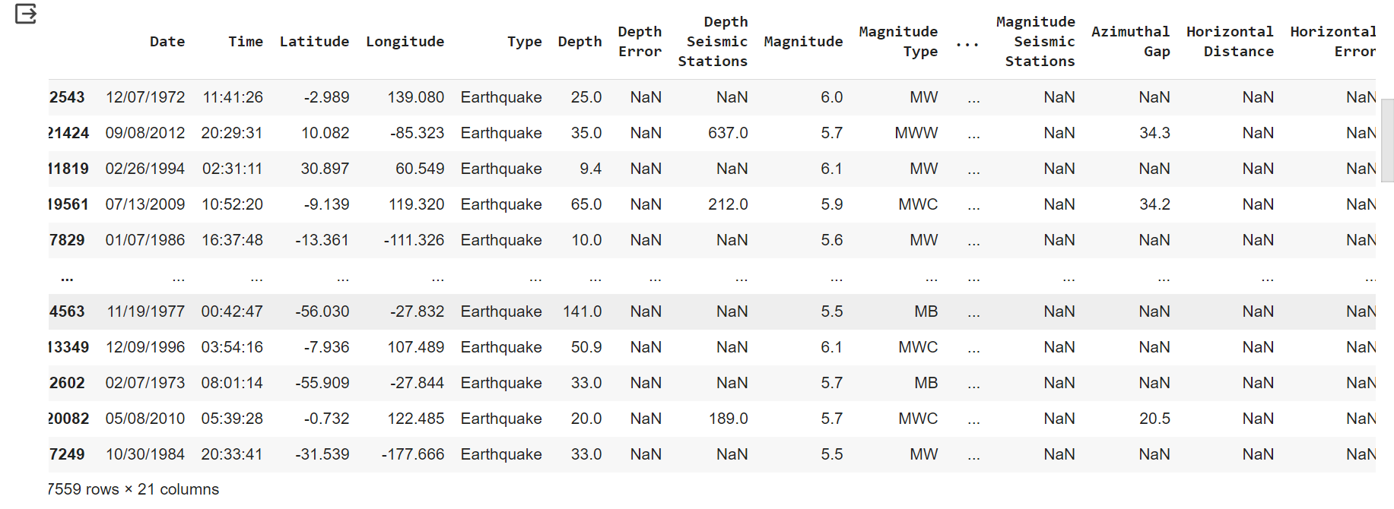

X_train, X_test, y_train, y_test = train_test_split(data, data["Magnitude"], test_size=0.25)

data = data[['Date', 'Time', 'Latitude', 'Longitude', 'Depth', 'Magnitude']]

   data.head()

**output:**

|  |  |  |  |  |  |  |
| --- | --- | --- | --- | --- | --- | --- |
| **index** | **date** | **Time** | **lattitude** | **longitude** | **Depth** | **magnitude** |
| 0 | 01/02/1965 | 13:44:18 | 19.246 | 145.616 | 131.6 | 6.0 |
| 1 | 01/04/1965 | 11:29:49 | 1.863 | 127.352 | 80.0 | 5.8 |
| 2 | 01/05/1965 | 18:05:58 | -20.579 | -173.972 | 20.0 | 6.2 |
| 3 | 01/08/1965 | 18:49:43 | -20.579 | 23.557 | 15.0 | 5.8 |
| 4 | 01/09/1965 | 13:32:50 | 11.938 | 126.427 | 15.0 | 5.8 |

import datetime

import time

timestamp = []

for d, t in zip(data['Date'], data['Time']):

    try:

        ts = datetime.datetime.strptime(d+' '+t, '%m/%d/%Y %H:%M:%S')

        timestamp.append(time.mktime(ts.timetuple()))

    except ValueError:

        # print('ValueError')

        timestamp.append('ValueError')

timeStamp = pd.Series(timestamp)

data['Timestamp'] = timeStamp.values

final_data = data.drop(['Date', 'Time'], axis=1)

final_data = final_data[final_data.Timestamp != 'ValueError']

final_data.head()

**output:**

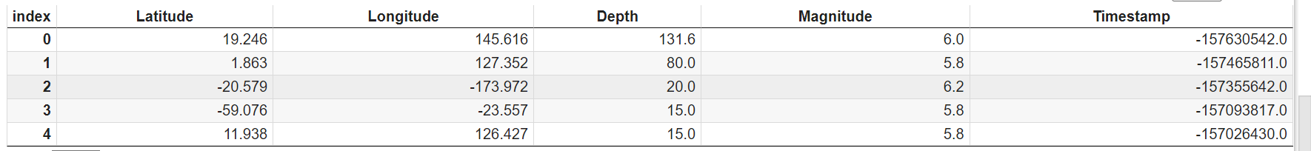

actual_earthquakes = [1, 0, 1, 1, 0, 0, 1, 0, 1, 1]

predicted_earthquakes = [1, 0, 0, 1, 1, 0, 1, 1, 1, 0]

accuracy = accuracy_score(actual_earthquakes, predicted_earthquakes)

precision = precision_score(actual_earthquakes, predicted_earthquakes)

recall = recall_score(actual_earthquakes, predicted_earthquakes)

f1 = f1_score(actual_earthquakes, predicted_earthquakes)

print(f'Accuracy: {accuracy}')

print(f'Precision: {precision}')

print(f'Recall: {recall}')

print(f'F1 Score: {f1}')

**output:**

Accuracy: 0.6

Precision: 0.6666666666666666

Recall: 0.6666666666666666

F1 Score: 0.6666666666666666

**Conclusion:**

In conclusion, developing an earthquake prediction model is a highly complex and challenging endeavor that requires a multidisciplinary approach, combining expertise in geology, seismology, and data science. While the ultimate goal of accurately predicting earthquakes remains elusive due to the inherent unpredictability of these natural events, the design thinking process can guide the development of models that contribute to early warning systems and disaster preparedness efforts.

In summary, while complete earthquake prediction remains a formidable scientific challenge, the development of models based on the principles of design thinking, with collaboration, data, and advanced algorithms at their core, can contribute to improved disaster preparedness and mitigation efforts. The goal is not only to predict earthquakes but also to save lives and minimize the impact of these natural disasters on communities.